# CloudWatch Performance Monitoring

CloudWatch Dashboard can be built dynamically allow administrators to visualize system metrics. Below are metrics for host health and latency render as numbers and stacked and line graphs.

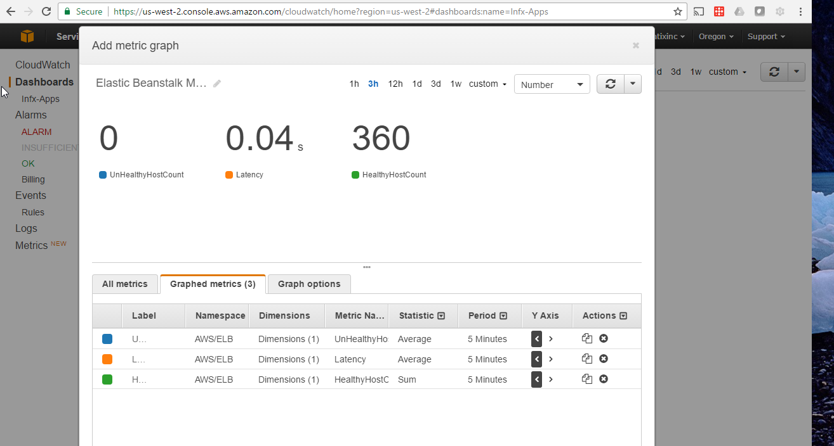

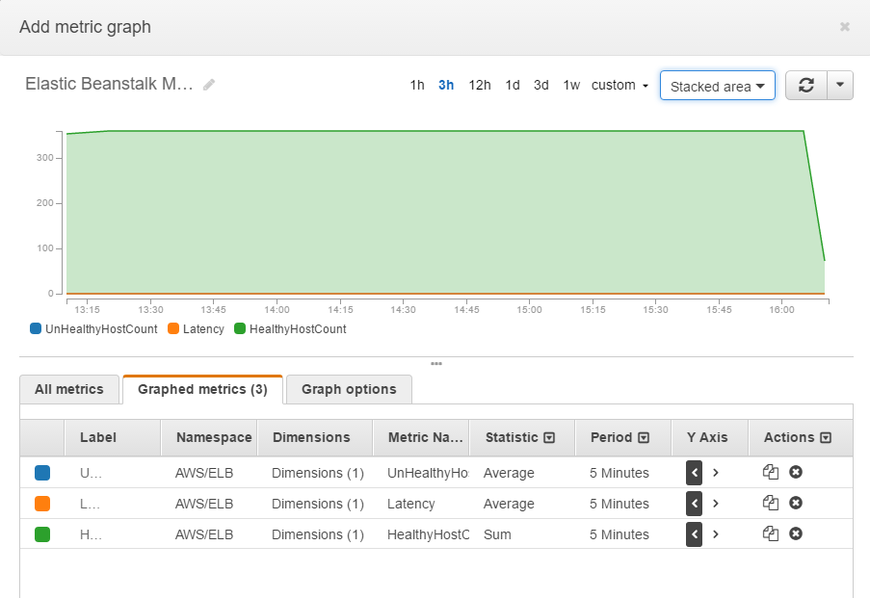

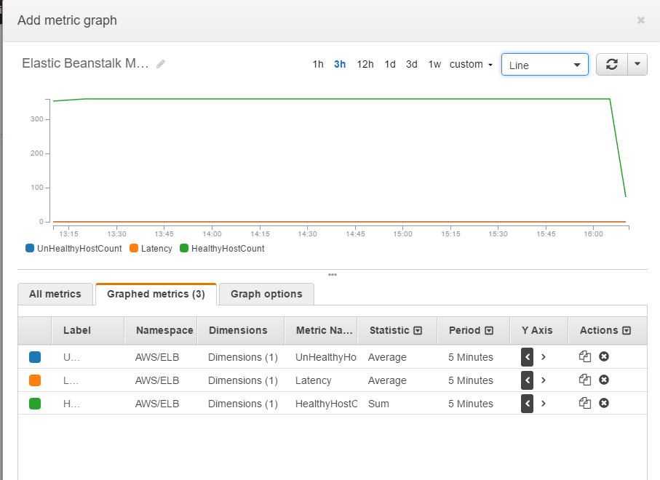

This shows Cal Notify system Log Groups.

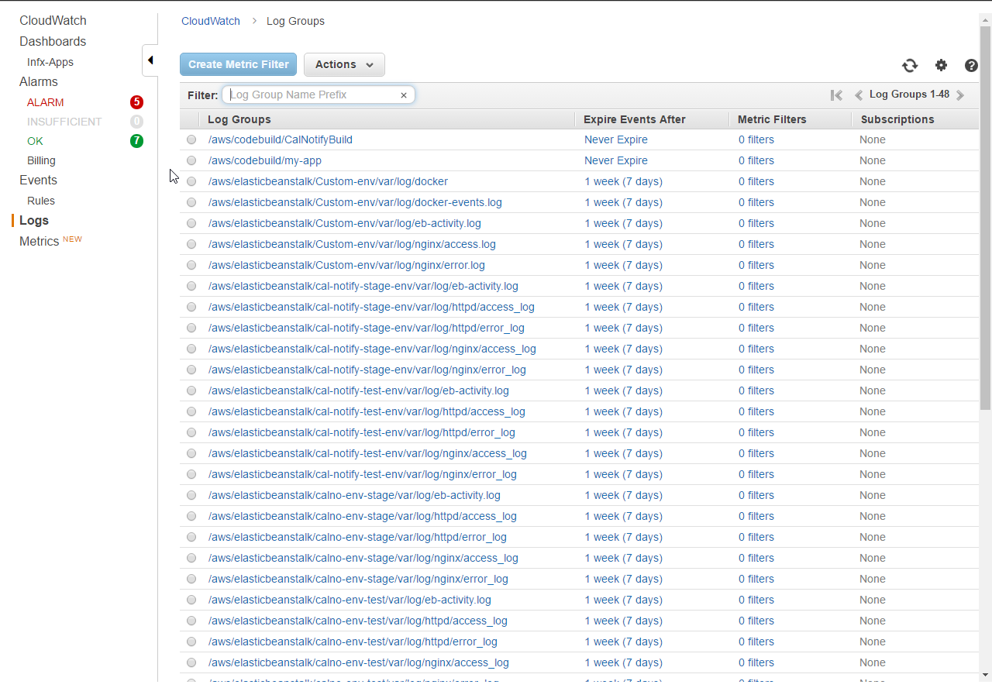

Define and create alarms triggered base upon environment help. Configure actions to take in the case of an event. Below, notification is sent to and admin SNS topic and the system is auto-scaled.

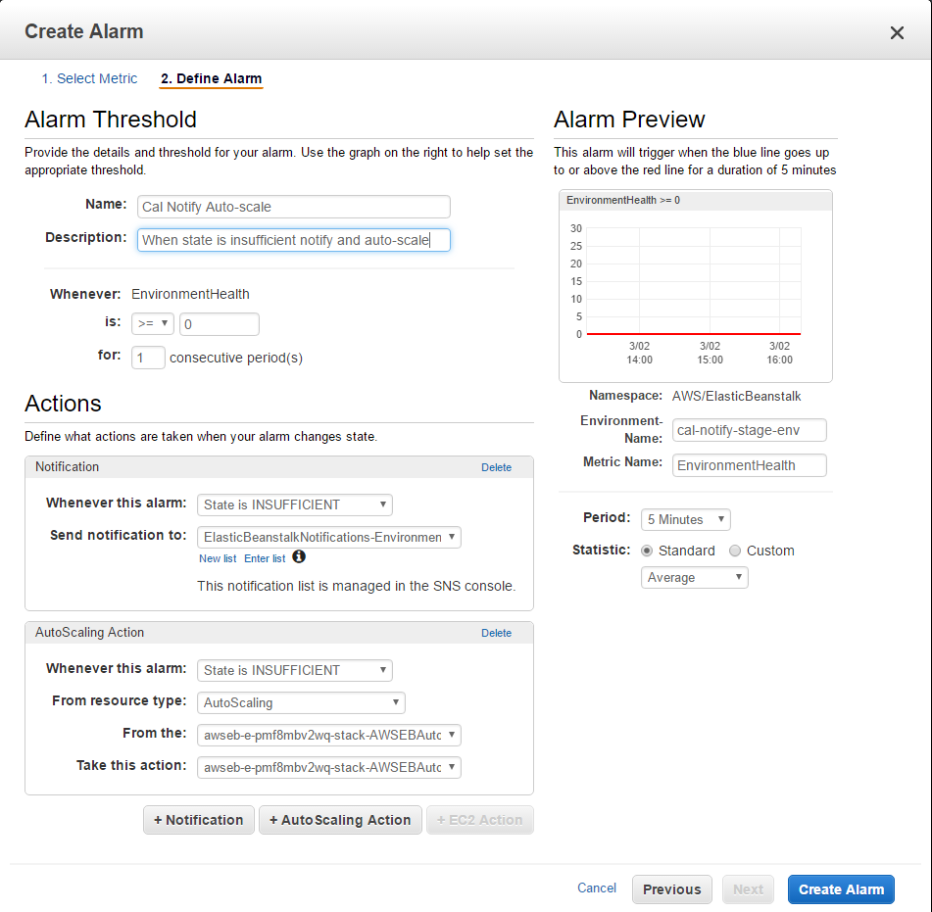

Create rules to invoke Targets based on Events happening in your Cal Notify environment.

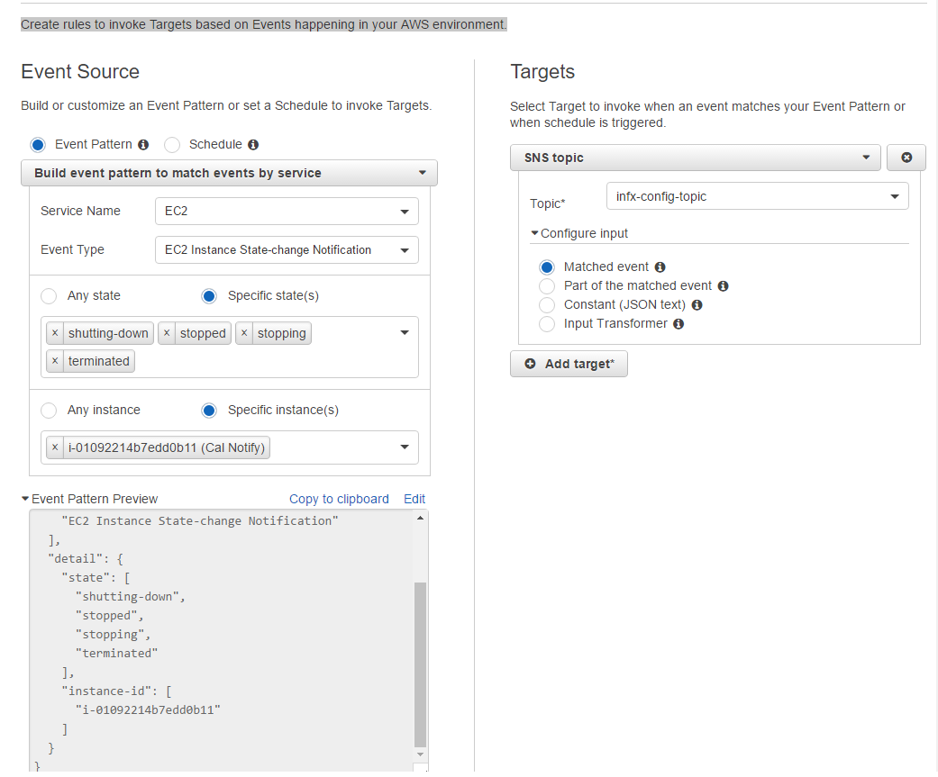

Dynamically char performance metrics of Cal Notify EC2 instances.

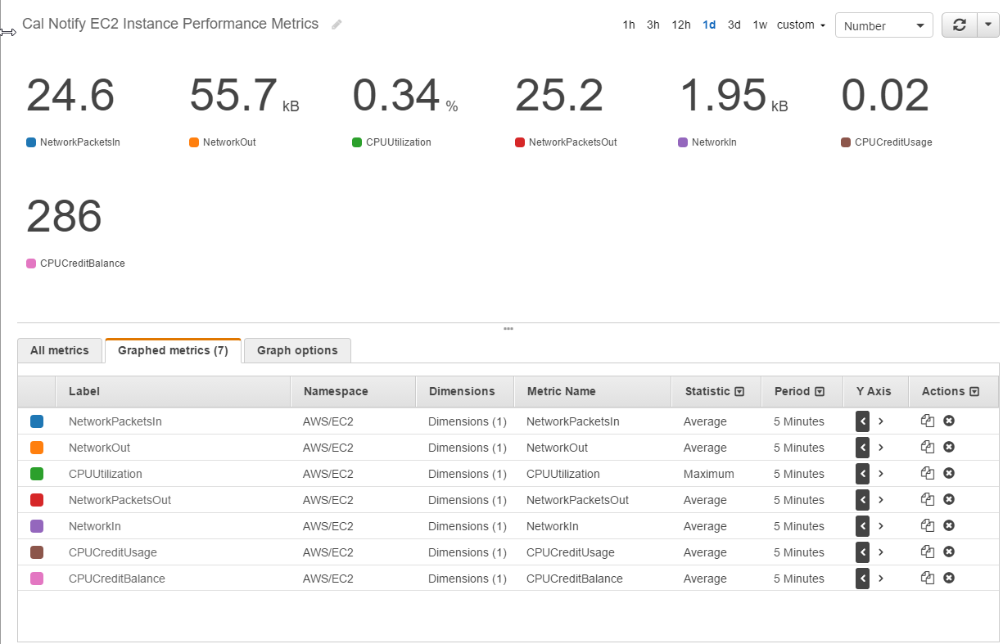

Finally, tools too continuously monitor environment health.